MATERIAL SAFETY DATA SHEET — 16 Sections
SECTION 1 — CHEMICAL PRODUCT AND COMPANY IDENTIFICATION
Product Identifier  Freedom Lube |  |  |  | [WHMIS Classification]
Product Use
Metal Lubricant, Protectant and Cleaner.
Manufacturer’s Name  Freedom Line Products, LLC |  |  | Supplier’s Name  Freedom Line Products, LLC
Street Address  Forsyth Georgia |  |  | Street Address  Forsyth Georgia
City  Forsyth |  | Province | City  Forsyth |  |  | Province
Postal Code  30297 | Emergency Telephone  (865) 551-9056 |  | Postal Code  30297 |  | Emergency Telephone  (865) 551-9056
Date MSDS Prepared  June 28, 2018 |  | MSDS Prepared By  C. M. W. |  | Phone Number  (865) 551-9056

SECTION 2 — COMPOSITION/INFORMATION ON INGREDIENTS
Hazardous Ingredients (specific) | % | CAS Number | GHS Hazard Code
1. Trade Secret | 50-<60% | not considered to be hazardous, Mixture | N/A
2. Trade Secret | 10-<12% | not considered to be hazardous | N/A
3. Trade Secret | 12.5%  1-<2%  4-<6%  <1% | 64742-54-7  Confidential  68037-01-4  67124-09-8 | H304  H413  H304  H317, H400 & H410(Mfactor1)
4. Trade Secret | 1-<13%  1-<3% | Mixture  Proprietary | N/A  N/A

Route of Entry
❐ Skin Contact ❐ Skin Absorption ❐ Eye Contact ❐ Inhalation ❐ Ingestion
Signal Word: Warning
[mergency Overview

WHMIS Symbol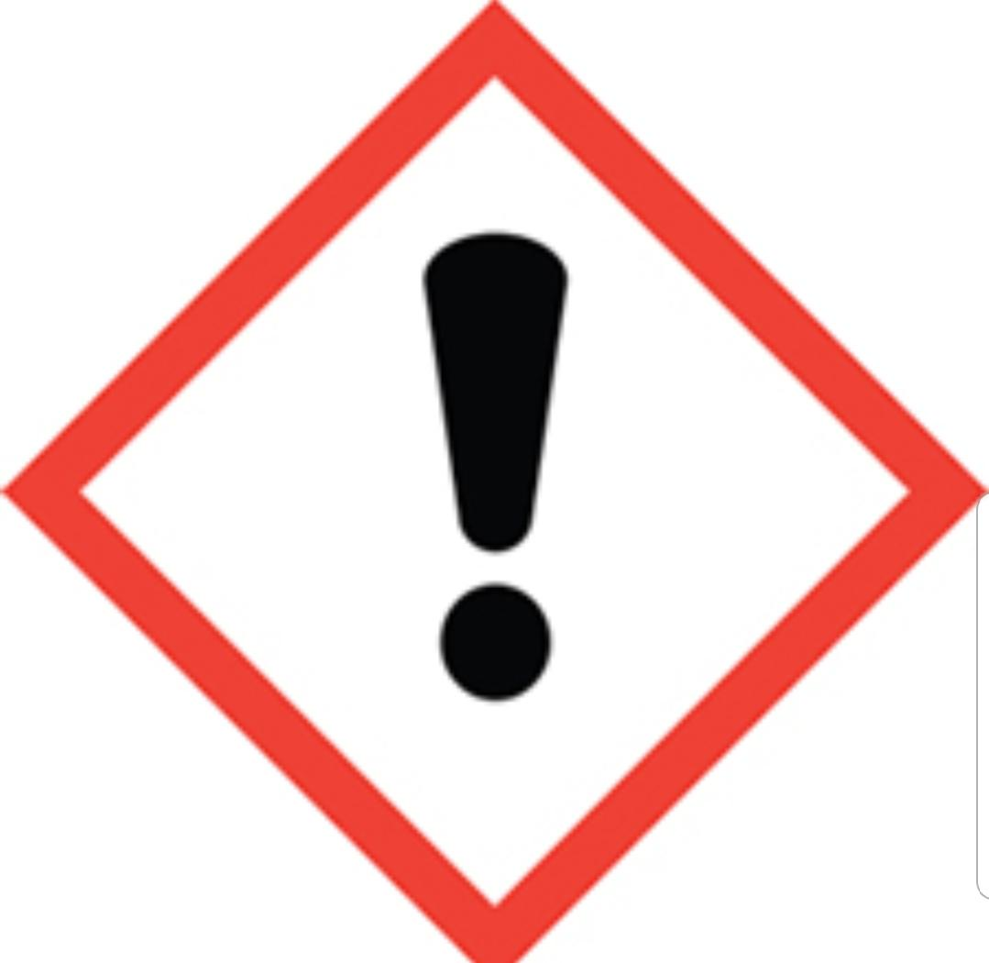
Potential Health Effects- H317: May cause allergic skin reaction. Skin sensitizer category 1. Contains: Alkylacetamide; Alkylamine. Physical / Chemical Hazards: no significant hazards. Could cause irritation to the skin or eyes with excessive exposure.
Keep out reach of children. Read label before use. Wash contaminated clothing before reuse. Dispose of contents and container in accordance with local regulations. Avoid release to the environment. Wash exposed areas with plenty of soap and water. Of skin irritation or rash occurs: Get medical advice/attention.
Wear protective gloves with repeated excessive exposure.
SECTION 3 — HAZARDS IDENTIFICATION

SECTION 4 — FIRST AID MEASURES
Skin Contact-Wash contact areas with soap and water. Remove contaminated clothing. Launder contaminated clothing before reuse. If product is injected into or under skin, or into any part of the body, regardless of the appearance of the wound or its size, the individual should be evaluated immediately by a physician as a surgical emergency. Even though initial symptoms from high pressure injection may be minimal or absent, early surgical treatment with in the first few hours may significantly reduce the ultimate extent of the injury.

Eye Contact- Flush thoroughly with water immediately. If irritation occurs, get medical assistance.
Inhalation-Remove from further exposure. For those providing assistance, avoid exposure to yourself or others. Use adequate respiratory protection. If respiratory irritation, dizziness, nausea, or unconsciousness occurs, seek immediate medical assistance. If breathing has stopped, assist ventilation with a mechanical device or use mouth-to-mouth resuscitation or cardio pulmonary resuscitation (CPR).
Ingestion-First Aid is normally not required. Do not induce vomiting. Treat symptomatically. Seek medical attention if discomfort occurs.
57M6 (6/99) Please continue on reverse side
SECTION 5 — FIRE FIGHTING MEASURES

Flammable  ❐Yes❐ No | If yes, under which conditions?  High Heat, Open Flames
Means of Extinction-
Appropriate Extinguishing Media: Use water fog, Foam, dry chemical or carbon dioxide (CO2) to extinguish flames.
Inappropriate Extinguishing Media: Straight streams of water or high pressure water jet.

Flashpoint (° C) and Method  >177 [ASTM D-92] | Upper Flammable Limit (% by volume)  7.0 | Lower Flammable Limit (% by volume)  0.9
Auto ignition Temperature (°C)  N/A- None Known | Explosion Data — Sensitivity to Impact  N/A | Explosion Data — Sensitivity to Static Discharge  N/A
Hazardous Combustion Products-
Smoke, Fume, Aldehydes, Sulfur oxides, Incomplete combustion products, Oxides of Carbon, Aldehydes and Ketones and other hazardous gases or vapors.
Fire Fighting Instructions: Evacuate area. Prevent runoff from fire control or dilution from entering streams, sewers, or drinking water supply. Firefighters should use standard protective equipment and in enclosed spaces, self-contained breathing apparatus (SCBA). Use water spray to cool fire exposed surfaces and to protect personnel.

SECTION 6 — ACCIDENTAL RELEASE MEASURES
Leak and Spill Procedures:
Notification Procedures: In the event of a spill or accidental release, notify relevant authorities in accordance with all applicable regulations. US regulations require reporting releases of this material to the environment which exceed the applicable reportable quantity or oil spills which could reach any waterway including intermittent dry creeks. The National Response Center can be reached at (800)424-8802.
Spill: Stop leak if you can do it without risk. Confine spill immediately. Spillage could constitute a slipping hazard. Prevent spill from entering water ways, sewers, basements or confined areas. For land spill, recover by using suitable absorbent. For water spill, confine spill immediately, remove from surface by skimming or with suitable absorbents. Seek the advice of specialist before using dispersants. Wear suitable personal protective equipment.

SECTION 7 — HANDLING AND STORAGE

Avoid contact with skin. Prevent small spills and leakage to avoid slip hazard. Material can accumulate static charges which may cause electric spark. This material is a static accumulator.
Consult local applicable standards for guidance. Additional references include American Petroleum Institute 2003 (Protection Against Ignitions Arising out of Static, Lighting and Stray Currents) or National Fire Protection Agency 77 (Recommended Practice on Static Electricity).
Do not store in open or unlabeled containers. Keep away from high heat or open flame. Do not cut or weld on or near empty containers or drums. Store in a ventilated place in securely closed original containers.
Store out of reach of children in a secured container.

Storage Requirements-
Handling Procedures and Equipment-
SECTION 8 — EXPOSURE CONTROL / PERSONAL PROTECTION
Exposure Limits  ❐ ACGIH TLV | ❐ OSHA PEL |  | ❐ Other (specify)
Specific Engineering Controls (such as ventilation, enclosed process)

Comply with applicable environmental regulations limiting discharge to air, water and soil. Protect the environment by applying appropriate control measures to prevent or limit emissions.
Personal Protective Equipment ❐ Gloves ❐ Respirator | ❐ Eye | ❐ Footwear | ❐ Clothing | ❐ Other
If checked, please specify type
Gloves- Chemical gloves (such as Nitrile rubber gloves) recommended for extended exposure.
Eye- If contact is likely, chemical goggles should be used
Clothing-No skin protection is ordinarily required under normal conditions of use. If usage
is prolonged or extensive, repeated contact, oil resistant chemical clothing should be considered.
Work Hygiene Measures- Good personal hygiene measures should always be conducted, such as washing hand with soap and water after exposer and before eating or drinking. Launder contaminated clothing after exposer. Keep work areas clean and removed from contaminates.

SECTION 9 — PHYSICAL AND CHEMICAL PROPERTIES
Materials to avoid: strong oxidizers
Physical State  Liquid | Odor and Appearance  Characteristic, Red | Odour Threshold (ppm)  N/D
Specific Gravity  N/D | Vapor Density (air = 1)  >2 at 101 KPA | Vapor Pressure (mmHg)  N/D
Evaporation Rate  N/D | Flash Point (° C)  >239.44 | Freezing Point (° C)  unknown
pH  N/A | Coefficient of Water/Oil Distribution  >3.5 | [Solubility in Water]  Negligible

SECTION 10 — STABILITY AND REACTIVITY

Chemical Stability | ❐Yes ❐ No |  | If no, under which conditions?  N/A
Incompatibility with Other Substances |  | ❐Yes ❐ No | If yes, which ones?  Strong oxidizers
Reactivity, and under what conditions? Material is stable under normal conditions.

Hazardous Decomposition Products: none
SECTION 11 — TOXICOLOGICAL INFORMATION

Effects of Acute Exposure:
Minimally Toxic. Based on assessment of the components.
Effects of chronic exposure: Minimally Toxic. Based on assessment of the components.
Irritancy of Product: May cause short-lasting discomfort with eyes.
Skin sensitization: Negligible irritation on skin at ambient temperatures. Does contain a substance that may cause a skin sensitization. | Respiratory sensitization: Not expected to be a respiratory sensitizer.
Carcinogenicity-IARC: Not a carcinogenic | Carcinogenicity – ACGIH: Not carcinogenic
Reproductive toxicity: Minimally Toxic. | Teratogenicity: Not expected to cause harm to breast fed children.
Embrotoxicity: Not expected to be a reproductive toxicant. | Mutagenicity; Not expected to be mutagenic.
Name of synergistic products/effects. N/D

SECTION 12 — ECOLOGICAL INFORMATION
[Aquatic Toxicity] Product contains material expected to be harmful to aquatic organisms. May cause long-term adverse effects in the aquatic environment.
SECTION 13 — DISPOSAL CONSIDERATIONS

Product is suitable for burning in an enclosed controlled burner for fuel value or disposal by supervised incineration at very high temperatures to prevent formation of undesirable combustion products. Protect the environment. Dispose of in accordance with all local, state and federal regulations.
Minimize skin contact. Do not mix oil with solvents or coolants.
Waste Disposal: The unused product, in our opinion, is not specifically listed by the EPA as a hazardous waste, nor is it formulated to contain materials which are listed as hazardous wastes.
SECTION 14 — TRANSPORT INFORMATION

LAND (DOT): Not regulated for land transport
LAND (TDG): Not regulated for land transport
SEA (IMDG): Not regulated for sea transport
AIR (IATA): Not regulated for air transport
None
Not regulated for land transport | Not regulated for land transport
Not Regulated | Not regulated

SECTION 15 — REGULATORY INFORMATION
TDG
Special Shipping Information
[IMO]
[DOT]
[ICAO]
PIN
[WHMIS Classification] |  | [OSHA]
[SARA] (311/312)  None  No hazard |  | [TSCA]
This product has been classified in accordance with the hazard criteria of the
Controlled Products Regulations (CPR) and the MSDS contains all of the information required by CPR.

SECTION 16 — OTHER INFORMATION
Disclaimer: The information and recommendations contained herein are, the best of Freedom Line Products’ knowledge and belief, accurate and reliable as of the date issued. You can contact Freedom Line Products to insure that this document is the most current available from Freedom Line Products. The information and recommendations are offered for the user’s consideration and examination. It is the user’s responsibility to satisfy itself that the product is suitable for the intended use. If the buyer repackages this product, it is the user’s responsibility to insure proper health, safety and other necessary information is included with and/or on the container. Appropriate warnings and safe-handling procedures should be provided to handlers and users
Note: This material should not be used for any other purpose that the intended use in Section 1 without expert advice. Health studied have shown that chemical exposure may cause potential human health risks which may vary from person to person.

